**Ideation Phase**

**Brainstorm & Idea Prioritization**

|  |  |
| --- | --- |
| Date | 25 November 2025 |
| Team ID |  |
| Project Name | BookStore |
| Maximum Marks | 4 Marks |

**Step-1: Team Gathering, Collaboration and Select the Problem Statement**

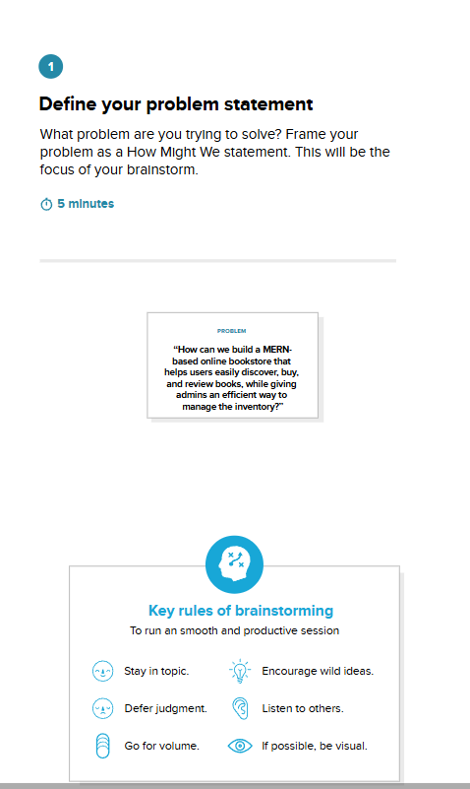

**STEP 2: Brainstorm, Idea Listing and Grouping**

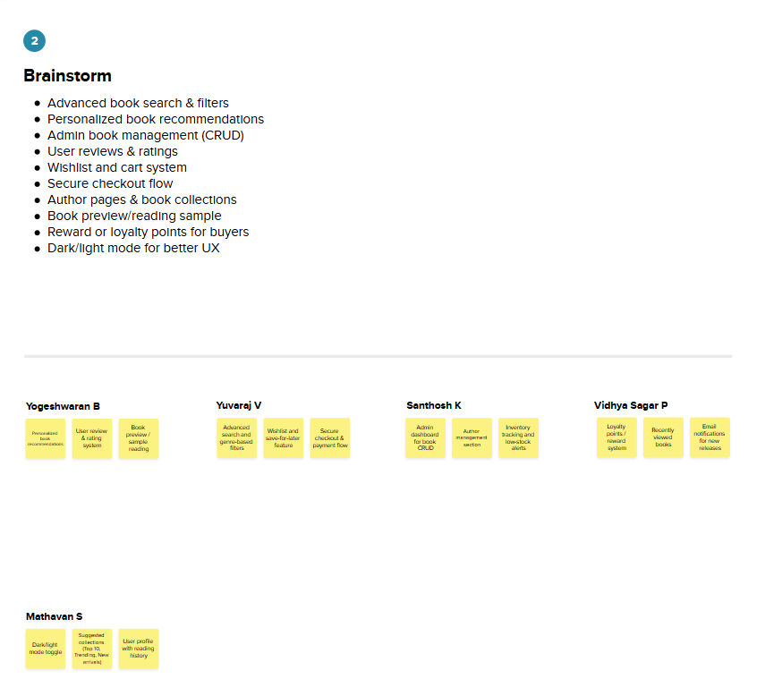

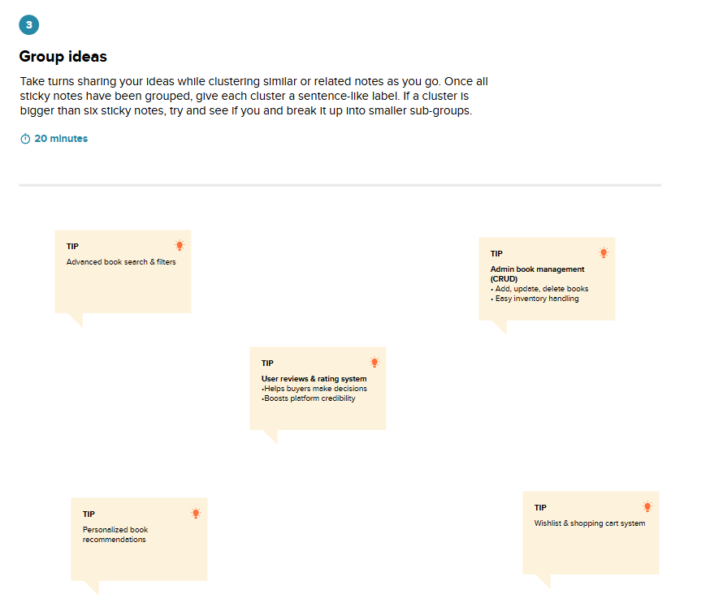

**STEP 3: Idea Prioritization**

